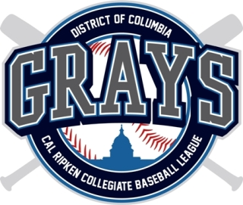

DC GRAYS 2017

PROSPECT INFORMATION FORM

Please return via E-mail to: Antonio Scott (General Manager) Antonio@dcgrays.com

THIS IS NOT A PLAYER CONTRACT
First Name | Last Name
College/University |  | Current Class Standing
Position(s) Bats/Throws |  | Height  Weight
Birth Date  Month: Day: Year : |  | Mobile Phone
Email Address

College Coach / Contact | Coach Phone

Coach Email
Past Summer team / League
Have you previously been selected in the Major League Draft? If yes, provide name of team and round selected below:

Name of team and round selected
Have you ever played for a professional team? If so, please indicate what team, league and date of release:
Do you need housing for the summer? | Will you bring a car? |  | Any allergies or medical issues?

